1. Design ERD Conceptual & Physical (Relational) di Data Modeller

Logical:

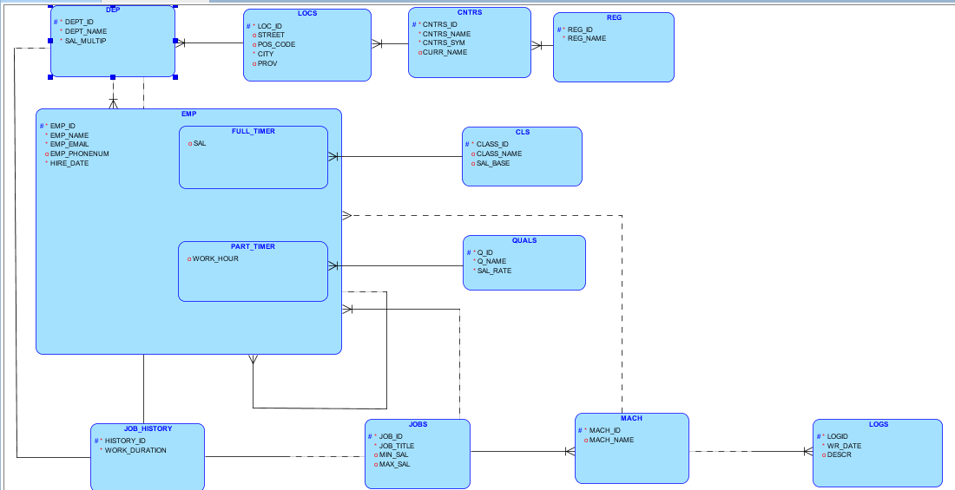

Relational :

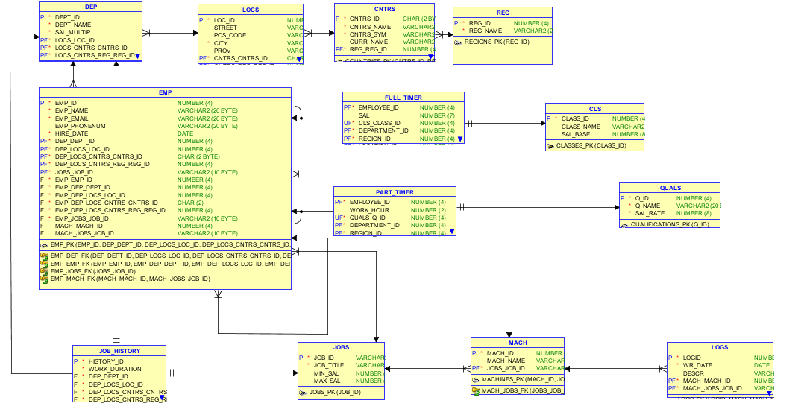

1. Syntax DDL

|  |
| --- |
| CREATE TABLE cls (  class_id NUMBER(4) NOT NULL,  class_name VARCHAR2(20 BYTE),  sal_base NUMBER(8)  );  ALTER TABLE cls ADD CONSTRAINT classes_pk PRIMARY KEY ( class_id );  CREATE TABLE cntrs (  cntrs_id CHAR(2 BYTE) NOT NULL,  cntrs_name VARCHAR2(30 BYTE) NOT NULL,  cntrs_sym VARCHAR2(3 BYTE) NOT NULL,  curr_name VARCHAR2(20 BYTE),  reg_reg_id NUMBER(4) NOT NULL  );  ALTER TABLE cntrs ADD CONSTRAINT countries_pk PRIMARY KEY ( cntrs_id,  reg_reg_id );  CREATE TABLE dep (  dept_id NUMBER(4) NOT NULL,  dept_name VARCHAR2(20 BYTE) NOT NULL,  sal_multip NUMBER(4) NOT NULL,  locs_loc_id NUMBER(4) NOT NULL,  locs_cntrs_cntrs_id CHAR(2 BYTE) NOT NULL,  locs_cntrs_reg_reg_id NUMBER(4) NOT NULL  );  ALTER TABLE dep  ADD CONSTRAINT departments_pk PRIMARY KEY ( dept_id,  locs_loc_id,  locs_cntrs_cntrs_id,  locs_cntrs_reg_reg_id );  CREATE TABLE emp (  emp_id NUMBER(4) NOT NULL,  emp_name VARCHAR2(20 BYTE) NOT NULL,  emp_email VARCHAR2(20 BYTE) NOT NULL,  emp_phonenum VARCHAR2(20 BYTE),  hire_date DATE NOT NULL,  dep_dept_id NUMBER(4) NOT NULL,  dep_locs_loc_id NUMBER(4) NOT NULL,  dep_locs_cntrs_cntrs_id CHAR(2 BYTE) NOT NULL,  dep_locs_cntrs_reg_reg_id NUMBER(4) NOT NULL,  jobs_job_id VARCHAR2(10 BYTE) NOT NULL,  emp_emp_id NUMBER(4) NOT NULL,  emp_dep_dept_id NUMBER(4) NOT NULL,  emp_dep_locs_loc_id NUMBER(4) NOT NULL,  emp_dep_locs_cntrs_cntrs_id CHAR(2) NOT NULL,  emp_dep_locs_cntrs_reg_reg_id NUMBER(4) NOT NULL,  emp_jobs_job_id VARCHAR2(10 BYTE) NOT NULL,  mach_mach_id NUMBER(4),  mach_jobs_job_id VARCHAR2(10 BYTE)  );  ALTER TABLE emp  ADD CONSTRAINT emp_pk PRIMARY KEY ( emp_id,  dep_dept_id,  dep_locs_loc_id,  dep_locs_cntrs_cntrs_id,  dep_locs_cntrs_reg_reg_id,  jobs_job_id );  CREATE TABLE full_timer (  employee_id NUMBER(4) NOT NULL,  sal NUMBER(7),  cls_class_id NUMBER(4) NOT NULL,  department_id NUMBER(4) NOT NULL,  region_id NUMBER(4) NOT NULL,  location_id NUMBER(4) NOT NULL,  job_id VARCHAR2(10 BYTE) NOT NULL,  country_id CHAR(2) NOT NULL  );  ALTER TABLE full_timer  ADD CONSTRAINT full_timer_pk PRIMARY KEY ( employee_id,  department_id,  location_id,  country_id,  region_id,  job_id );  ALTER TABLE full_timer ADD CONSTRAINT full_timer_pkv1 UNIQUE ( cls_class_id );  CREATE TABLE job_history (  history_id NUMBER(4) NOT NULL,  work_duration INTERVAL DAY(9) TO SECOND(0) NOT NULL,  dep_dept_id NUMBER(4) NOT NULL,  dep_locs_loc_id NUMBER(4) NOT NULL,  dep_locs_cntrs_cntrs_id CHAR(2) NOT NULL,  dep_locs_cntrs_reg_reg_id NUMBER(4) NOT NULL,  jobs_job_id VARCHAR2(10 BYTE) NOT NULL,  dep_dept_id1 NUMBER(4) NOT NULL,  dep_locs_loc_id2 NUMBER(4) NOT NULL,  dep_locs_cntrs_cntrs_id2 CHAR(2 BYTE) NOT NULL,  dep_locs_cntrs_reg_reg_id2 NUMBER(4) NOT NULL  );  CREATE UNIQUE INDEX job_history__idx ON  job_history (  dep_dept_id  ASC,  dep_locs_loc_id  ASC,  dep_locs_cntrs_cntrs_id  ASC,  dep_locs_cntrs_reg_reg_id  ASC );  CREATE UNIQUE INDEX job_history__idxv1 ON  job_history (  jobs_job_id  ASC );  CREATE UNIQUE INDEX job_history__idx ON  job_history (  dep_dept_id1  ASC,  dep_locs_loc_id2  ASC,  dep_locs_cntrs_cntrs_id2  ASC,  dep_locs_cntrs_reg_reg_id2  ASC );  ALTER TABLE job_history ADD CONSTRAINT job_history_pk PRIMARY KEY ( history_id );  CREATE TABLE jobs (  job_id VARCHAR2(10 BYTE) NOT NULL,  job_title VARCHAR2(20 BYTE) NOT NULL,  min_sal NUMBER(5),  max_sal NUMBER(6)  );  ALTER TABLE jobs ADD CONSTRAINT jobs_pk PRIMARY KEY ( job_id );  CREATE TABLE locs (  loc_id NUMBER(4) NOT NULL,  street VARCHAR2(40 BYTE),  pos_code VARCHAR2(5),  city VARCHAR2(20) NOT NULL,  prov VARCHAR2(20),  cntrs_cntrs_id CHAR(2 BYTE) NOT NULL,  cntrs_reg_reg_id NUMBER(4) NOT NULL  );  ALTER TABLE locs  ADD CONSTRAINT locations_pk PRIMARY KEY ( loc_id,  cntrs_cntrs_id,  cntrs_reg_reg_id );  CREATE TABLE logs (  logid NUMBER(4) NOT NULL,  wr_date DATE NOT NULL,  descr VARCHAR2(30 BYTE),  mach_mach_id NUMBER(4) NOT NULL,  mach_jobs_job_id VARCHAR2(10 BYTE) NOT NULL  );  ALTER TABLE logs  ADD CONSTRAINT logs_pk PRIMARY KEY ( logid,  mach_mach_id,  mach_jobs_job_id );  CREATE TABLE mach (  mach_id NUMBER(4) NOT NULL,  mach_name VARCHAR2(30 BYTE),  jobs_job_id VARCHAR2(10 BYTE) NOT NULL  );  ALTER TABLE mach ADD CONSTRAINT machines_pk PRIMARY KEY ( mach_id,  jobs_job_id );  CREATE TABLE part_timer (  employee_id NUMBER(4) NOT NULL,  work_hour NUMBER(2),  quals_q_id NUMBER(4) NOT NULL,  department_id NUMBER(4) NOT NULL,  region_id NUMBER(4) NOT NULL,  location_id NUMBER(4) NOT NULL,  job_id VARCHAR2(10 BYTE) NOT NULL,  country_id CHAR(2) NOT NULL  );  ALTER TABLE part_timer  ADD CONSTRAINT part_timer_pk PRIMARY KEY ( employee_id,  department_id,  location_id,  country_id,  region_id,  job_id );  ALTER TABLE part_timer ADD CONSTRAINT part_timer_pkv1 UNIQUE ( quals_q_id );  CREATE TABLE quals (  q_id NUMBER(4) NOT NULL,  q_name VARCHAR2(20 BYTE) NOT NULL,  sal_rate NUMBER(8) NOT NULL  );  ALTER TABLE quals ADD CONSTRAINT qualifications_pk PRIMARY KEY ( q_id );  CREATE TABLE reg (  reg_id NUMBER(4) NOT NULL,  reg_name VARCHAR2(20 BYTE) NOT NULL  );  ALTER TABLE reg ADD CONSTRAINT regions_pk PRIMARY KEY ( reg_id );  ALTER TABLE cntrs  ADD CONSTRAINT cntrs_reg_fk FOREIGN KEY ( reg_reg_id )  REFERENCES reg ( reg_id );  ALTER TABLE dep  ADD CONSTRAINT dep_locs_fk FOREIGN KEY ( locs_loc_id,  locs_cntrs_cntrs_id,  locs_cntrs_reg_reg_id )  REFERENCES locs ( loc_id,  cntrs_cntrs_id,  cntrs_reg_reg_id );  ALTER TABLE emp  ADD CONSTRAINT emp_dep_fk FOREIGN KEY ( dep_dept_id,  dep_locs_loc_id,  dep_locs_cntrs_cntrs_id,  dep_locs_cntrs_reg_reg_id )  REFERENCES dep ( dept_id,  locs_loc_id,  locs_cntrs_cntrs_id,  locs_cntrs_reg_reg_id );  ALTER TABLE emp  ADD CONSTRAINT emp_emp_fk FOREIGN KEY ( emp_emp_id,  emp_dep_dept_id,  emp_dep_locs_loc_id,  emp_dep_locs_cntrs_cntrs_id,  emp_dep_locs_cntrs_reg_reg_id,  emp_jobs_job_id )  REFERENCES emp ( emp_id,  dep_dept_id,  dep_locs_loc_id,  dep_locs_cntrs_cntrs_id,  dep_locs_cntrs_reg_reg_id,  jobs_job_id );  ALTER TABLE emp  ADD CONSTRAINT emp_jobs_fk FOREIGN KEY ( jobs_job_id )  REFERENCES jobs ( job_id );  ALTER TABLE emp  ADD CONSTRAINT emp_mach_fk FOREIGN KEY ( mach_mach_id,  mach_jobs_job_id )  REFERENCES mach ( mach_id,  jobs_job_id );  ALTER TABLE full_timer  ADD CONSTRAINT full_timer_cls_fk FOREIGN KEY ( cls_class_id )  REFERENCES cls ( class_id );  ALTER TABLE full_timer  ADD CONSTRAINT full_timer_employees_fk FOREIGN KEY ( employee_id,  department_id,  location_id,  country_id,  region_id,  job_id )  REFERENCES emp ( emp_id,  dep_dept_id,  dep_locs_loc_id,  dep_locs_cntrs_cntrs_id,  dep_locs_cntrs_reg_reg_id,  jobs_job_id );  ALTER TABLE job_history  ADD CONSTRAINT job_history_dep_fk FOREIGN KEY ( dep_dept_id,  dep_locs_loc_id,  dep_locs_cntrs_cntrs_id,  dep_locs_cntrs_reg_reg_id )  REFERENCES dep ( dept_id,  locs_loc_id,  locs_cntrs_cntrs_id,  locs_cntrs_reg_reg_id );  ALTER TABLE job_history  ADD CONSTRAINT job_history_dep_fkv1 FOREIGN KEY ( dep_dept_id1,  dep_locs_loc_id2,  dep_locs_cntrs_cntrs_id2,  dep_locs_cntrs_reg_reg_id2 )  REFERENCES dep ( dept_id,  locs_loc_id,  locs_cntrs_cntrs_id,  locs_cntrs_reg_reg_id );  ALTER TABLE job_history  ADD CONSTRAINT job_history_jobs_fk FOREIGN KEY ( jobs_job_id )  REFERENCES jobs ( job_id );  ALTER TABLE locs  ADD CONSTRAINT locs_cntrs_fk FOREIGN KEY ( cntrs_cntrs_id,  cntrs_reg_reg_id )  REFERENCES cntrs ( cntrs_id,  reg_reg_id );  ALTER TABLE logs  ADD CONSTRAINT logs_mach_fk FOREIGN KEY ( mach_mach_id,  mach_jobs_job_id )  REFERENCES mach ( mach_id,  jobs_job_id );  ALTER TABLE mach  ADD CONSTRAINT mach_jobs_fk FOREIGN KEY ( jobs_job_id )  REFERENCES jobs ( job_id );  ALTER TABLE part_timer  ADD CONSTRAINT part_timer_employees_fk FOREIGN KEY ( employee_id,  department_id,  location_id,  country_id,  region_id,  job_id )  REFERENCES emp ( emp_id,  dep_dept_id,  dep_locs_loc_id,  dep_locs_cntrs_cntrs_id,  dep_locs_cntrs_reg_reg_id,  jobs_job_id );  ALTER TABLE part_timer  ADD CONSTRAINT part_timer_quals_fk FOREIGN KEY ( quals_q_id )  REFERENCES quals ( q_id ); |

1. Screenshot Bukti Struktur Tabel Telah Dibuat di SQL Developer

* Department

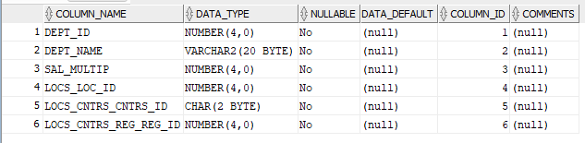

* Location

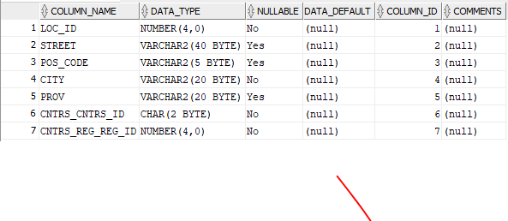

* Countries

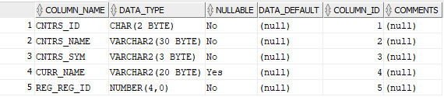

* Regions

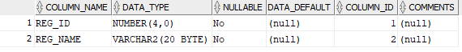

* Employee

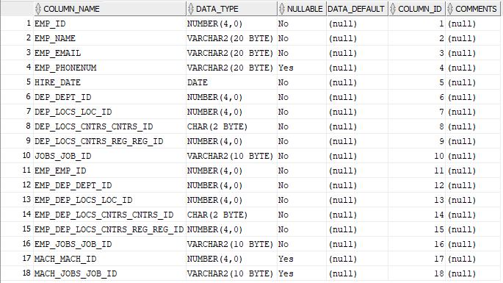

* Full_timer

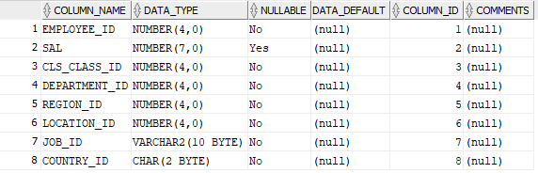

* Part_timer

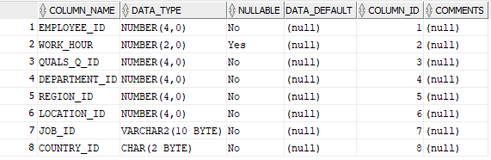

* Classes

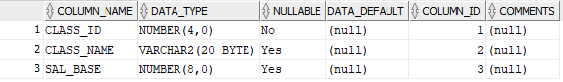

* Qualification

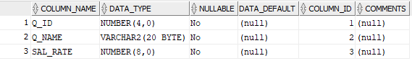

* Job_history

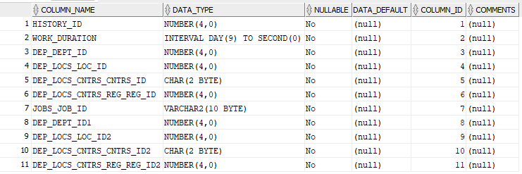

* Jobs

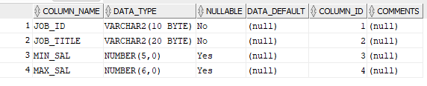

* Machine

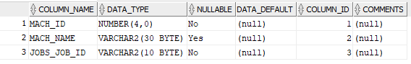

* Logs

